AI Governance Evidence Infrastructure:
A Category Framework for Cryptographically Verifiable AI Lifecycle Accountability

Denzil Greenwood
Founder and Head Researcher, CognitiveInsight.ai
Draft prepared for concept development and publication planning

April 18, 2026
This draft frames AI Governance Evidence Infrastructure as a distinct category and introduces the umbrella architecture that later papers will deepen.

Abstract
AI governance has matured faster in policy and documentation than in verifiable evidence. Across regulated and high-stakes environments, organizations increasingly maintain policies, model cards, risk registers, validation reports, ticket trails, and operational telemetry, yet these artifacts often remain fragmented, weakly linked, and difficult to verify as a coherent chain of accountability. Emerging governance regimes emphasize lifecycle controls, record-keeping, transparency, and oversight rather than one-time documentation alone. This paper argues that current tooling categories-observability, MLOps, model documentation, and GRC-do not by themselves solve the accountability problem for high-stakes AI. They are valuable, but they are not the same as a durable evidence layer that can produce cryptographically verifiable proof of what happened, why it happened, under what authority it happened, and whether governance controls were enforced. Accordingly, this paper proposes a new category: AI Governance Evidence Infrastructure (AGEI). AGEI is defined as the architectural layer that captures, seals, links, stores, and retrieves verifiable governance evidence across the AI lifecycle. The paper introduces an integrated reference architecture composed of lifecycle evidence capture, governance gates, an evidence vault, agent governance planes, shadow-AI capture, and provenance mechanisms such as watermarking and forensic fingerprinting. The contribution is category-defining: it proposes vocabulary, boundaries, functional components, and stakeholder value for a class of systems designed not merely to document AI governance, but to prove it.
Keywords: AI governance, evidence infrastructure, accountability, lifecycle assurance, agent governance, provenance, watermarking, shadow AI
1. Introduction
The central problem of modern AI governance is not the absence of policies. It is the absence of proof. In many organizations, AI assurance is assembled from a patchwork of policy documents, approval tickets, screenshots, model cards, dashboards, and log files. These materials may be useful for operations, project management, or regulatory preparation, but they rarely form a tamper-evident, lifecycle-wide chain of evidence.
The mismatch is structural. Existing categories each address an important slice of the problem, but none is designed as a full evidence layer. Observability frameworks help operators understand system behavior by collecting telemetry. MLOps helps organizations build, deploy, and retrain models consistently. Model cards and system cards improve transparency around intended use, performance, and limitations. GRC and internal-control frameworks organize policy, risk, and compliance responsibilities. Yet evidence-grade accountability requires more than visibility, automation, or documentation. It requires verifiable continuity across events, controls, actors, and artifacts.
This paper is therefore category-defining rather than merely implementation-specific. It proposes AI Governance Evidence Infrastructure as the missing architectural category for high-stakes AI. Where observability asks what is happening and MLOps asks how to build and run models reliably, AGEI asks what evidence exists to prove what happened, why it happened, who authorized it, and whether required controls were enforced.

Definitions
AI Governance Evidence Infrastructure (AGEI): An architectural layer that captures, seals, links, stores, and retrieves verifiable governance evidence across the AI lifecycle. It moves beyond documentation to provide cryptographically verifiable proof of what happened, why it happened, and whether required controls were enforced.
Cognitive Insight Audit Framework (CIAF) is an AI governance evidence framework for representing, evaluating, and preserving governed AI events as structured, verifiable records across the AI lifecycle. Its purpose is to turn governance from static policy and fragmented logging into machine-evaluable control and durable evidence. In CIAF, lifecycle events such as data onboarding, training, validation, deployment, runtime decisions, agent actions, approvals, denials, and incidents are captured as evidence-bearing receipts that can be linked to policy state, control outcomes, and supporting artifacts. The framework is designed to support auditability, traceability, accountability, and post hoc verification in high-stakes AI systems.
Cognitive Insight Audit Framework (CIAF) - LCM: The foundational lifecycle model of the framework, in which AI events are represented as structured, evidence-bearing receipts across the AI lifecycle. LCM (Lazy Capsule Materialization) is the governing mechanism that enables continuous capture of lightweight operational footprints, while deferring assembly of heavier evidence capsules until triggered by governance events, audit demands, incidents, or review requirements. The system does not wait to capture governed events. It captures the operational text, context, and metadata required for governance at the time the event occurs, evaluates that information against policy-derived logic, and commits the resulting record to WORM storage. What is deferred is not capture, but the assembly of the fuller evidence capsule for regulators, auditors, legal review, incident response, and other situations requiring deeper inspection.
Governance Gates: Explicit control points placed at consequential lifecycle transitions, such as provenance, validation, deployment, or pre-action, that evaluate whether the conditions derived from versioned organizational governance policy have been satisfied and produce enforceable outcomes: Approve, Deny, Escalate, or Inspect.
Downstream Provenance: The mechanisms - specifically Explicit Watermarking and Forensic Fingerprinting - used to preserve evidentiary linkage between governed AI-generated artifacts and their origin after those artifacts leave the original runtime environment.
Shadow AI: Unmanaged or unsanctioned AI usage, such as public chatbots, browser extensions, embedded copilots, or third-party APIs, that occurs outside approved governance channels and creates visibility, control, and accountability gaps.
Receipt (Lifecycle Receipt): An atomic, structured evidence record that provides tamper-evident, independently verifiable proof of a specific lifecycle event, decision, or control outcome.

2. The Accountability Gap in Modern AI Systems
Modern AI systems generate abundant artifacts, but artifact abundance is not the same as accountability. Operational logs can show that an event occurred. A model card can summarize intended use and benchmark results. A ticket may show that someone clicked approve. A dashboard may show an accuracy trend. But these artifacts are often siloed, mutable, weakly linked, and optimized for operational convenience rather than evidentiary integrity.
Operational telemetry is indispensable for reliability engineering, but telemetry alone does not establish custody, authority, or non-repudiable governance state across a full AI lifecycle. MLOps platforms can automate model development, deployment, and monitoring, yet they are not typically designed to emit portable, signed receipts proving that a model promotion passed a required policy gate or that a deployment reflected an approved validation bundle.
Documentation-centered approaches have analogous limits. Model cards, system cards, and governance memos summarize and disclose. They do not, by themselves, create a cryptographically linked evidence trail for specific lifecycle events, runtime decisions, tool invocations, or downstream distributed artifacts.
3. Defining AI Governance Evidence Infrastructure
AI Governance Evidence Infrastructure is the architectural layer that generates, links, seals, stores, and retrieves verifiable evidence about AI lifecycle events, governance controls, actor authority, and downstream artifacts in order to support accountability in high-stakes environments.
AGEI is not equivalent to observability, MLOps, model cards, or GRC documentation. Observability is concerned with understanding internal state through telemetry; AGEI is concerned with proving governance-relevant facts through evidence structures. MLOps automates and standardizes machine-learning operations; AGEI attests to lifecycle decisions and control outcomes. Model cards and system cards are explanatory and disclosure artifacts; AGEI is evidentiary infrastructure. GRC can define required controls, but AGEI provides the machine-verifiable record that those controls were, or were not, actually executed.
The jobs-to-be-done for this category are specific: prove provenance, prove validation state, prove approval state, prove runtime policy enforcement, prove actor identity and authority, support post-incident reconstruction, and support portable export for audit, investigation, or dispute.
Table 1. Category comparison
Dimension | Observability | MLOps | GRC / model docs | AGEI
Primary purpose | Understand system behavior | Build and operate ML systems | Document policy, risk, and disclosures | Prove governance-relevant facts
Typical artifacts | Logs, traces, metrics | Pipelines, registries, deployment metadata | Policies, model cards, risk registers | Signed receipts, gate outcomes, audit bundles
Proof of authority | Limited | Incidental | Narrative | Explicit and verifiable
Lifecycle continuity | Partial | Strong for operations | Variable | Designed-in, cross-lifecycle
Portability for audit | Moderate | Variable | High for documents, low for proof | High by design

Figure 1 Category map
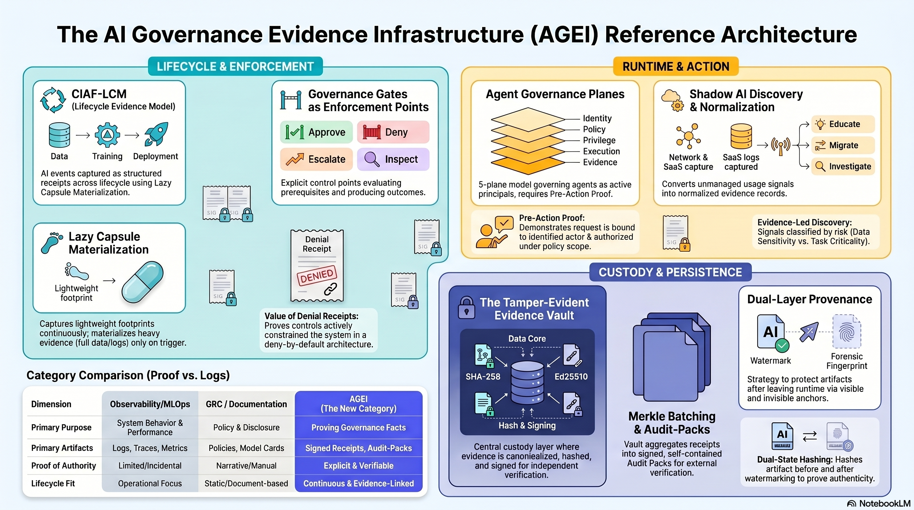
Category map showing CIAF-LCM, gates, vault, agents, shadow AI, and watermarking as one integrated architecture.

4. Core Architectural Components
The proposed AGEI reference architecture integrates six functional components.
First is the CIAF-LCM lifecycle evidence model, in which AI events are represented as structured, evidence-bearing receipts across data, training, validation, deployment, runtime, and incident handling. LCM denotes Lazy Capsule Materialization: lightweight operational footprints are captured continuously, evaluated against governance gates, and preserved as durable records. What is deferred is not event capture, but the assembly of heavier evidence capsules, which are materialized only when triggered by audits, incidents, inspections, or other governance requirements.
Second are governance gates. Gates are explicit control points placed at consequential transitions or actions: provenance gates before training, validation gates before model promotion, approval gates before deployment, and pre-action gates before an agent executes a sensitive tool call. Third is the evidence vault, the durable custody layer in which evidence objects are canonicalized, hashed, signed, linked, and stored for later verification and retrieval.
Fourth are agent governance plans: identity, policy, privilege, execution, and evidence.
Fifth is shadow-AI capture to extend the evidence perimeter to unmanaged or unsanctioned AI use.
Sixth are provenance mechanisms for downstream artifacts, including watermarking and forensic fingerprinting.
5. Lifecycle Model and Evidence Flow
An AGEI architecture is lifecycle-wide by design. At the data stage, evidence should capture lineage, acquisition or approval status, transformation events, and policy constraints. At the training stage, evidence should bind training runs to data roots, code versions, parameters, environment details, and validation prerequisites. At the validation stage, evidence should capture evaluation bundle identity, thresholds, regression outcomes, bias or safety checks where relevant, and reviewer or automated gate outcomes.
At deployment, evidence should bind release artifacts to the validated model state, the approving authority, and the policy context under which promotion occurred. At runtime inference, the question becomes not only which model version is in service, but what happened in this specific interaction.
For agentic systems, runtime evidence must also cover delegation and authority. If an agent retrieves customer data, approves a claim, changes a configuration, or sends an external communication, the evidence architecture should record the agent identity, the human or system principal on whose behalf it acted, the privilege scope granted, the policy evaluation performed, and the action receipt emitted. Incidents then require reconstructable chains across data, model state, controls, and actors; distributed artifacts require provenance that survives movement outside the original runtime boundary.
Figure 2 - Lifecycle evidence
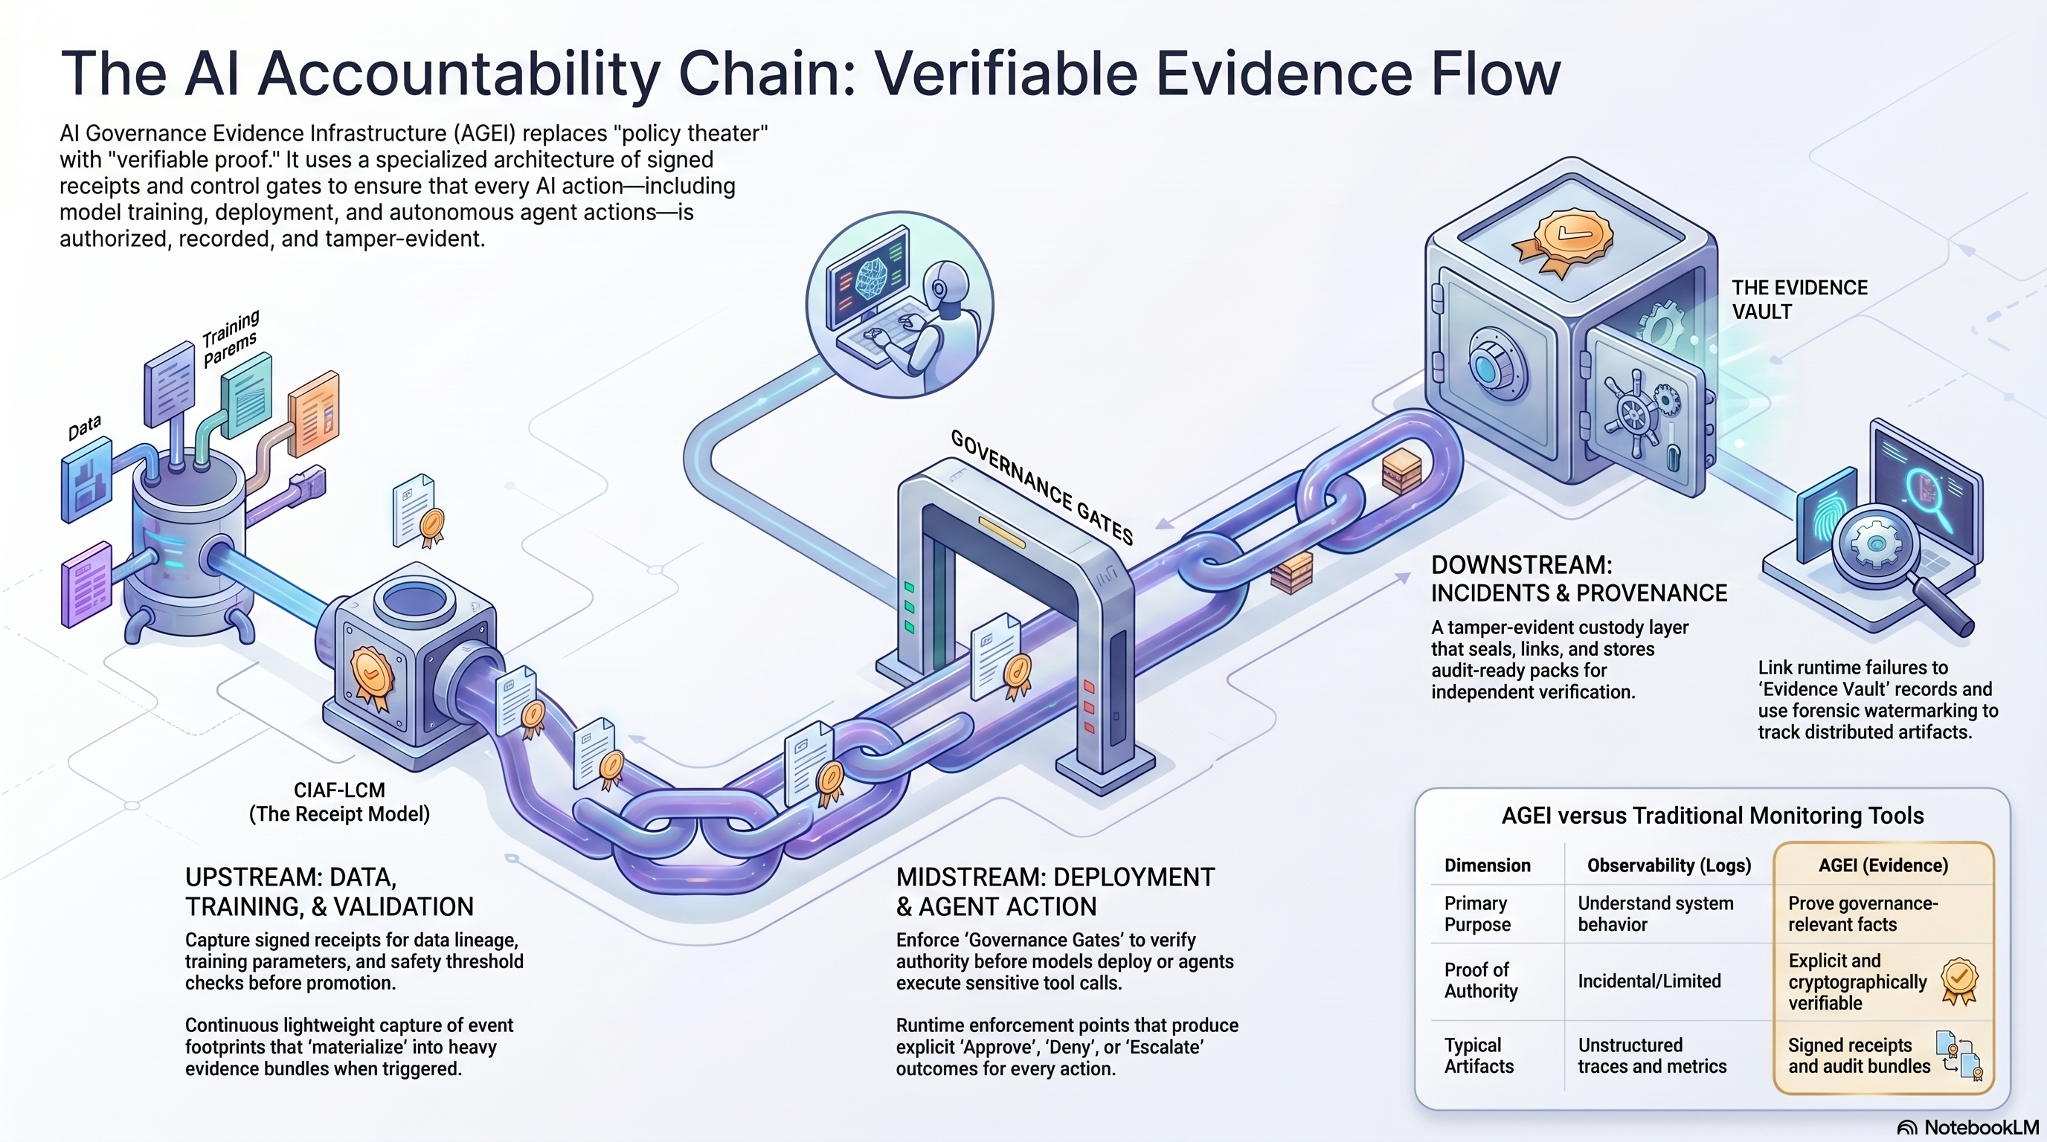
Lifecycle evidence flows from data and training through validation, deployment, runtime inference, agent action, incident response, and post-distribution artifact provenance.
6. Stakeholder Value and Control Outcomes
The relevance of AGEI differs by stakeholder, but the underlying value proposition is consistent: proof instead of inference.
For internal audit and control owners, AGEI provides testable evidence that required approvals, validations, and segregation-of-duties controls actually operated. For compliance teams, AGEI improves readiness for regimes that require record-keeping, traceability, oversight, and lifecycle management. For model risk teams, it adds evidentiary rigor around development, validation, use, and governance. For security leaders, it provides stronger attribution, privilege traceability, and post-incident reconstruction, especially for agents and cross-system automations. For legal teams, it improves the defensibility of provenance and process claims. For executives, it converts abstract responsible-AI commitments into measurable governance posture.
Table 2. Stakeholder outcomes
Stakeholder | Evidence need | Operational benefit
Internal audit | Control execution evidence | Faster testing and stronger defensibility
Compliance | Traceability and record-keeping | Improved readiness and evidence retrieval
Model risk management | Validation and governance continuity | Clearer challenge, review, and attestation
Security | Actor attribution and privilege traceability | Better post-incident reconstruction
Legal | Provenance and process integrity | Stronger dispute and inquiry response
Executive leadership | Trustworthy governance posture | Higher confidence in scaled AI deployment
Figure 3 Comparison graphic
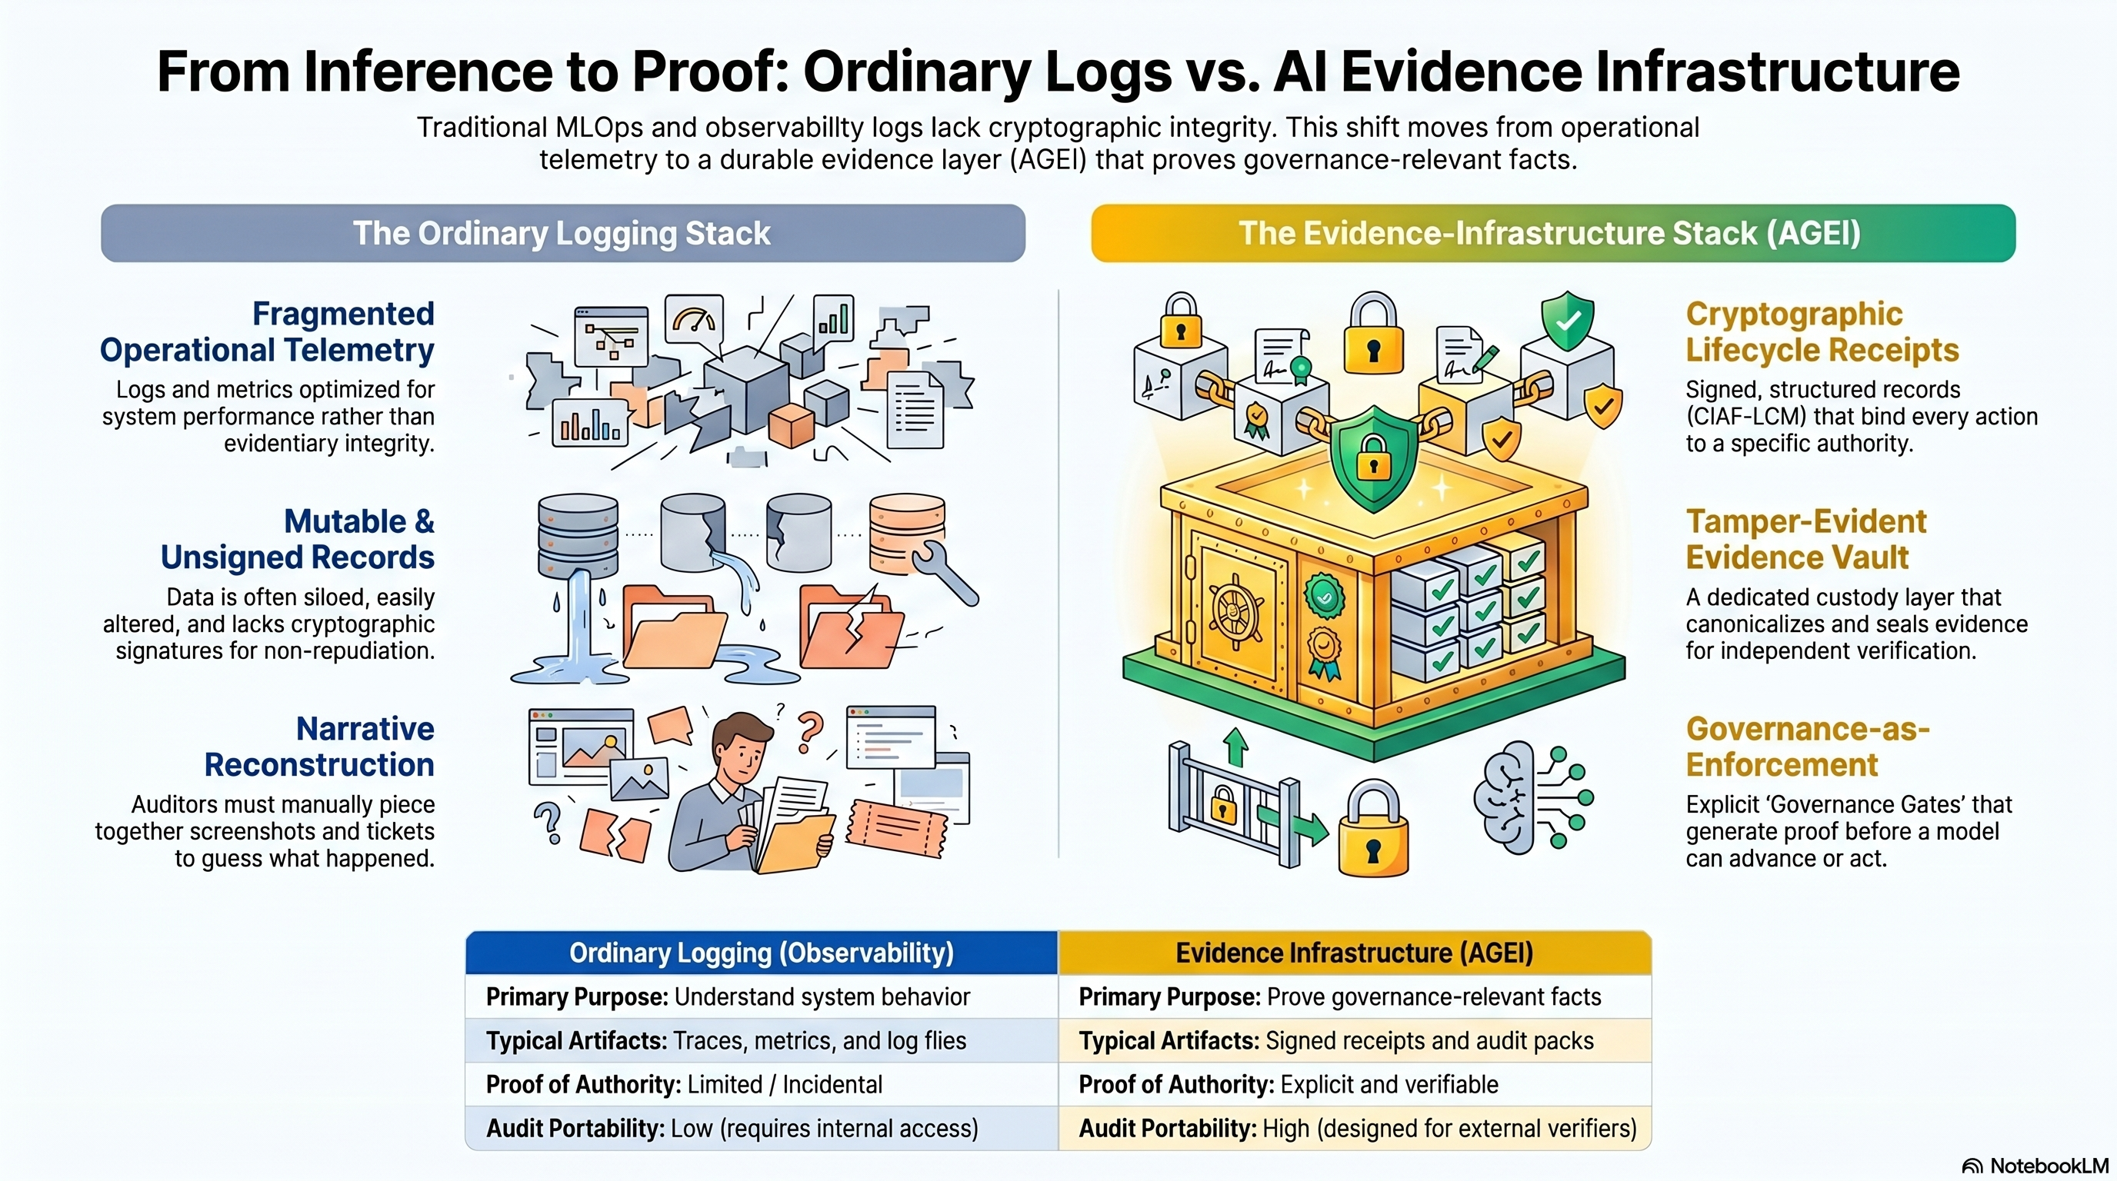
Comparison graphic showing an ordinary logging stack versus an evidence-infrastructure stack.
7. Example Use Cases
In credit and lending, governance disputes often hinge on lineage, validation, approval, and decision traceability. An AGEI architecture would bind decision events to model version, feature lineage or feature hashes, validation state, applicable policy gates, and approving authorities.
In healthcare and clinical decision support, lifecycle accountability is especially important because software behavior can affect patient safety and regulatory posture. AGEI would support stronger evidence around data provenance, evaluation status, human review, deployment state, and any downstream artifact provenance associated with clinical outputs.
In agentic enterprise workflows, the main risk is not only erroneous output but unverified action. AGEI provides a control fabric for agent identity, scoped privilege, policy mediation, and signed action receipts.
8. Limitations and Open Questions
This paper proposes a category, not a claim that all implementation questions are solved. Evidence capture introduces cost and design tradeoffs; not every event can or should be materialized at maximal granularity. Privacy and confidentiality boundaries matter. An evidence layer must avoid turning governance into indiscriminate surveillance or creating secondary risk by over-retaining sensitive prompts, inputs, or outputs.
The evidence layer itself becomes a governed system. Questions of key management, segregation of duties, vault integrity, retention, deletion, and third-party verification are central rather than incidental. Standardization also remains open: there is not yet a widely adopted technical standard for portable AI governance receipts, gate semantics, or artifact-level provenance exchange.
A further open question concerns proof strength. A screenshot, a mutable dashboard row, a signed event receipt, and a Merkle-anchored audit bundle do not offer the same assurance. One of the category's future tasks is to develop a vocabulary of evidence grades and verification profiles.
9. Conclusion
AI governance is entering a phase in which documentation, dashboards, and narrative controls are no longer sufficient on their own. Existing tooling categories remain necessary, but they do not fully answer the evidentiary question at the heart of high-stakes AI accountability.
This paper therefore proposes AI Governance Evidence Infrastructure as a distinct category. Its purpose is to provide cryptographically verifiable, lifecycle-wide proof of what happened, why it happened, under what authority it happened, and whether governance controls were enforced. Under this framing, CIAF-LCM, governance gates, an evidence vault, agent governance planes, shadow-AI capture, and provenance mechanisms such as watermarking are not separate projects. They are components of one integrated evidence architecture.
The follow-on work is clear. Subsequent papers should formalize lifecycle receipt schemas, gate semantics, evidence-vault custody models, agent governance planes, provenance methods for distributed artifacts, and shadow-AI evidence capture patterns. The category paper's role is narrower but foundational: to name the missing layer, define its boundaries, and establish why high-stakes AI needs proof, not logs.

References
[1] Regulation (EU) 2024/1689, Artificial Intelligence Act, Official Journal of the European Union, 2024.
[2] NIST, Artificial Intelligence Risk Management Framework (AI RMF 1.0), NIST AI 100-1, 2023.
[3] ISO/IEC 42001:2023, Information technology - Artificial intelligence - Management system.
[4] OpenTelemetry Documentation, 'What is OpenTelemetry?' and observability primer, OpenTelemetry project, accessed April 2026.
[5] Google Cloud, 'What is MLOps?' and related MLOps guidance, accessed April 2026.
[6] M. Mitchell et al., 'Model Cards for Model Reporting,' Proceedings of the Conference on Fairness, Accountability, and Transparency, 2019.
[7] Board of Governors of the Federal Reserve System and Office of the Comptroller of the Currency, Supervisory Guidance on Model Risk Management (SR 11-7), 2011.
[8] NIST, AI Agent Standards Initiative, 2026.

AI uses disclosure:

This document, "AI Governance Evidence Infrastructure: A Category Framework for Cryptographically Verifiable AI Lifecycle Accountability," was prepared for concept development and publication planning, dated April 18, 2026. It was authored by Denzil Greenwood, Founder and Head Researcher at CognitiveInsight.ai.
In the creation of this document, AI tools were utilized to generate both the text and the supporting images, with human oversight applied to both processes.

Research Papers and Continued Work: AI Governance Evidence Infrastructure
- Cognitive Insight Audit Framework Lazy Capsule Materialization (CIAF-LCM)
- Tamper-Evident Evidence Vault for AI Lifecycle Events, Decisions, and Audit Packs
- Dual-Layer Provenance for AI-Generated Artifacts: Explicit Watermarks and Forensic Fingerprints as Evidence Infrastructure
- Governance Planes for Agentic AI: Identity, Policy, Privilege, Execution, and Evidence
- Shadow AI Governance: Bringing Unmanaged AI Use into the Evidence Perimeter
- CIAF-LCM Proposed Schema Documentation: Current Schema State, Architecture Fit, and Proposed Documentation Model

